The 4th International Workshop

on Materials Issues for MEMS/MST Devices (IWMIMD)

(June 4-5, 2012)

Aim and Scope
MicroElectroMechanical System (MEMS)/Microsystem Technology (MST) devices have been applied in many fields including information, energy and bio-medical technologies, etc. Physical dimensions of components used in MEMS/MST devices are usually in a range from micron to nanometer scales, being comparable to microstructural scale of the material. Materials issues for these devices including micro-fabrication, characterization of microstructures/defects, and evaluation of mechanical properties of the materials are closely related to their performance, durability and reliability. The objective of this mini-workshop is to discuss and exchange ideas about the emerging issues relating application and preparation of small-scale materials for MEMS/MST devices, novel methods to characterize mechanical properties, understanding of size effects in the materials.

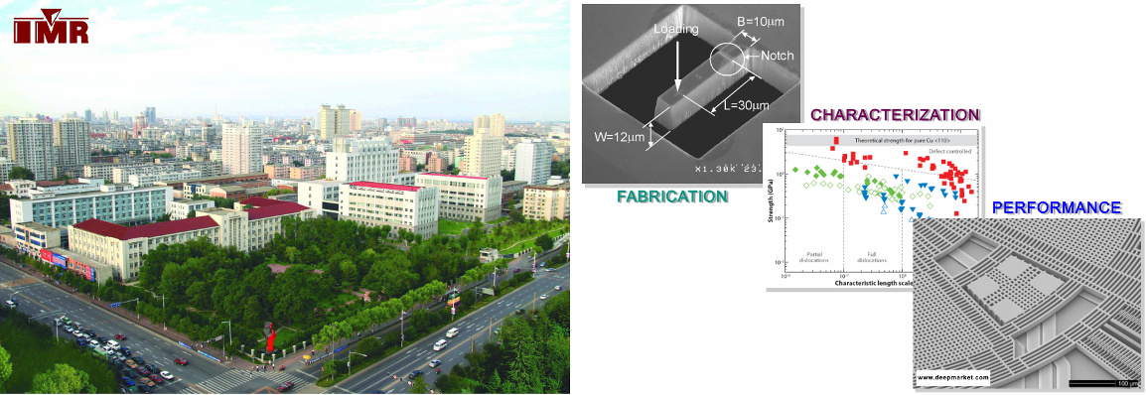

Venue:

Seminar Hall (No. 468), Lee Hsun Building

Institute of Metal Research, Chinese Academy of Sciences

72 Wenhua Road, Shenyang 110016

P. R. China

Chair of the 4th IWMIMD

Prof. Guang-Ping Zhang

Shenyang National Laboratory for Materials Science

Institute of Metal Research

Chinese Academy of Sciences

E-mail: gpzhang@imr.ac.cn

Invited Speakers
 | High and Very High Cycle Fatigue in Al and Cu Thin Films on Si Substrate  Prof. Oliver Kraft  Institute for Applied Materials - Materials and Biomechanics  Karlsruhe Institute of Technology
 | Observation of Deformation Behavior in Micro-sized Specimens by White-Light Interferometry  Prof. Kazuki Takashima  Department of Materials Science and Engineering  Kumamoto University
 | Alloying Effects on the Deformation Behavior of Nanocrystalline Metals  Dr. Ruth Schwaiger  Institute for Applied Materials - Materials and Biomechanics  Karlsruhe Institute of Technology
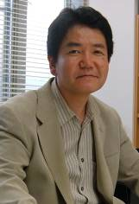 | MEMS Fluidic Variable Capacitor for the Application of Wide-Band GHz Filters  Prof. Kenichiro Suzuki  Department of Mechanical Engineering, School of engineering  Ritsumeikan University
 | Probing Materials' Properties and Reliability at the Micron Scale and the Need for New Experiments  Dr. Christoph Eberl  Institute for Applied Materials - Materials and Biomechanics  Karlsruhe Institute of Technology
 | Uniaxial Tensile Testing of Au Nanowires  Dr. Reiner Mönig  Institute for Applied Materials - Materials and Biomechanics  Karlsruhe Institute of Technology
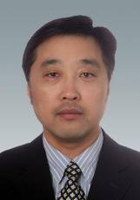 | Understanding of Fatigue Behavior of Freestanding Single Crystal Copper Foils at the Micrometer Scales  Prof. Guang-Ping Zhang  Shenyang National Lab. for Materials Science  Institute of Metal Research, Chinese Academy of Sciences

The 4th International Workshop

on Materials Issues for MEMS/MST Devices (IWMIMD)

(June 4, 2012)
Schedule
9:00-9:10 | Guang-Ping Zhang & Yakichi Higo |  | Opening remarks
Morning session
Session Chair: Yakichi Higo
9:10-9:50 | Oliver Kraft | High and very high cycle fatigue in Al and Cu thin films on Si substrate
9:50-10:30 | Kazuki Takashima | Observation of deformation behavior in micro-sized specimens by white-light interferometry
10:30-11:00 | Coffee break & Photo
11:00-11:40 | Ruth Schwaiger | Alloying effects on the deformation behavior of nanocrystalline metals
12:00-14:00 | Lunch and break
Afternoon session
Session Chair: Oliver Kraft
14:00-14:40 | Kenichiro Suzuki | MEMS fluidic variable capacitor for the application of wide-band GHz filters
14:40-15:20 | Christoph Eberl | Probing materials' properties and reliability at the micron scale and the need for new experiments
15:20-15:40 | Coffee break
15:40-16:20 | Reiner Mönig | Uniaxial tensile testing of Au nanowires
16:20-17:00 | Guang-Ping Zhang | Understanding of fatigue behavior of freestanding single crystal copper foils at the micrometer scales
 | Closing remarks
18:30-20:30 | Welcome banquet for all registered attendee

